SIEM - Splunk Project

Splunk installation

Step 1

Go to Splunk and create an account

Step 2

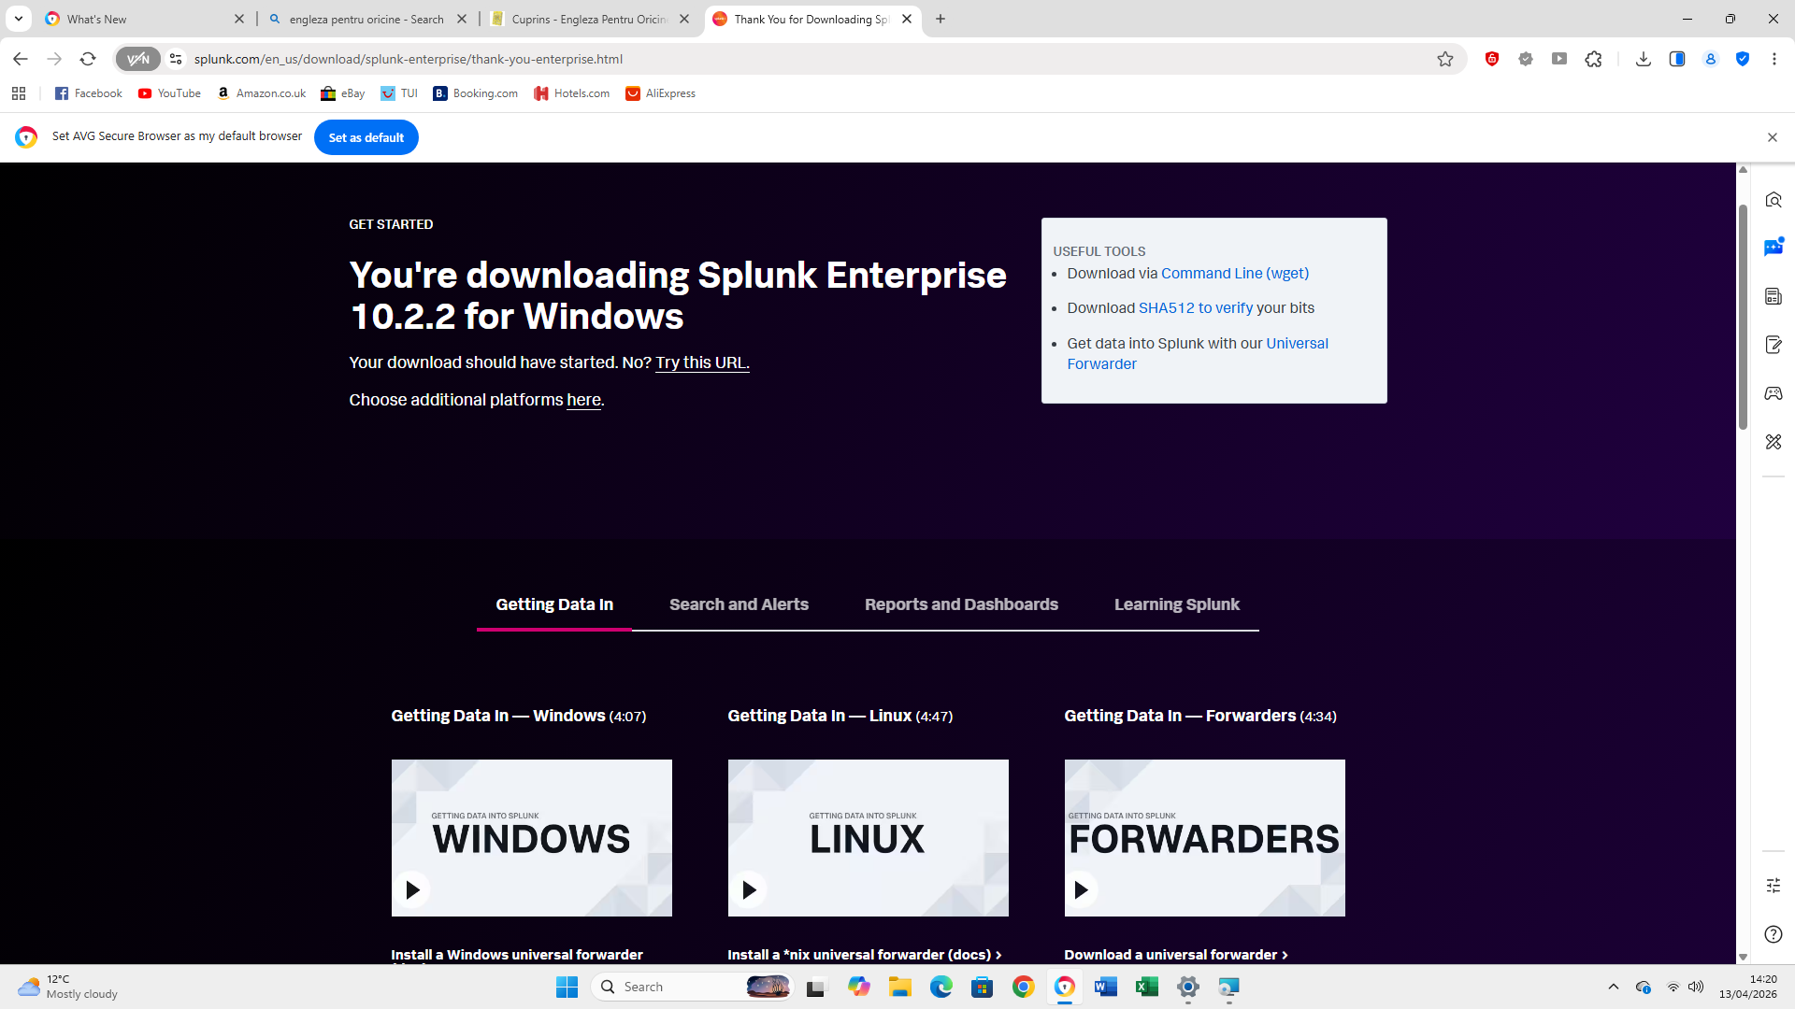
Download the corresponding Splunk Enterprise software for your OS (Windows in my case).
Step 3

Install Splunk and accept T&Cs
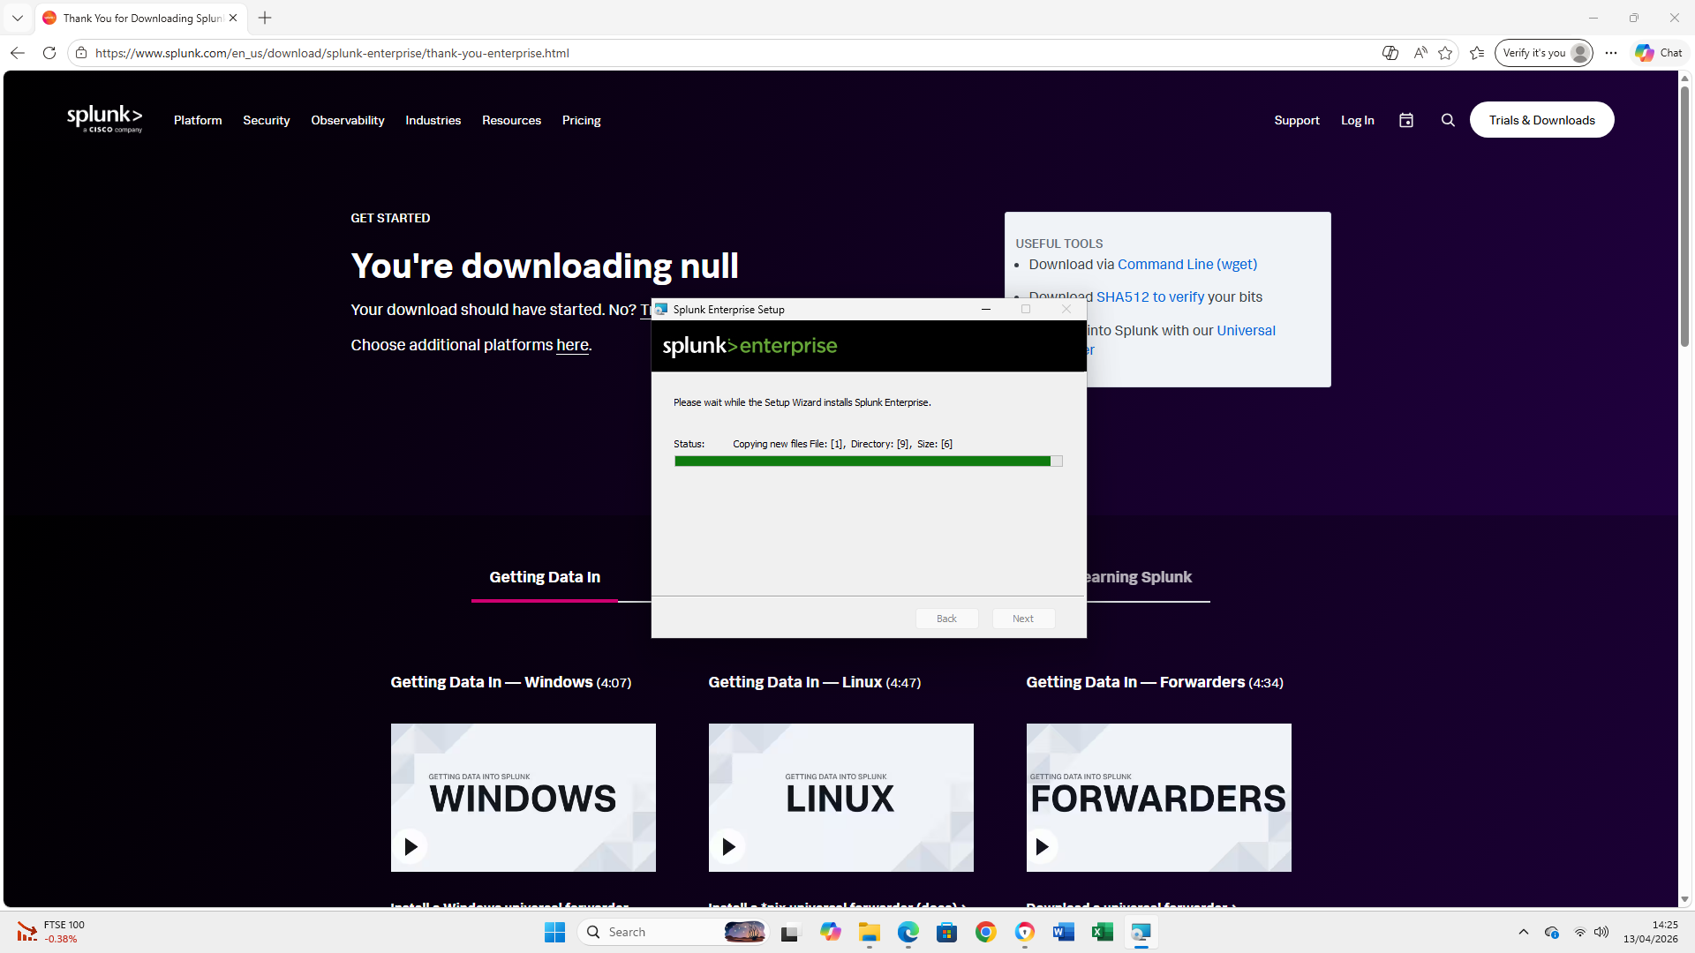

Data ingestion
Step 1
Once the installation process is finished data sources can be added to provide data we can analyze. Click Settings on top right corner and then Add data.
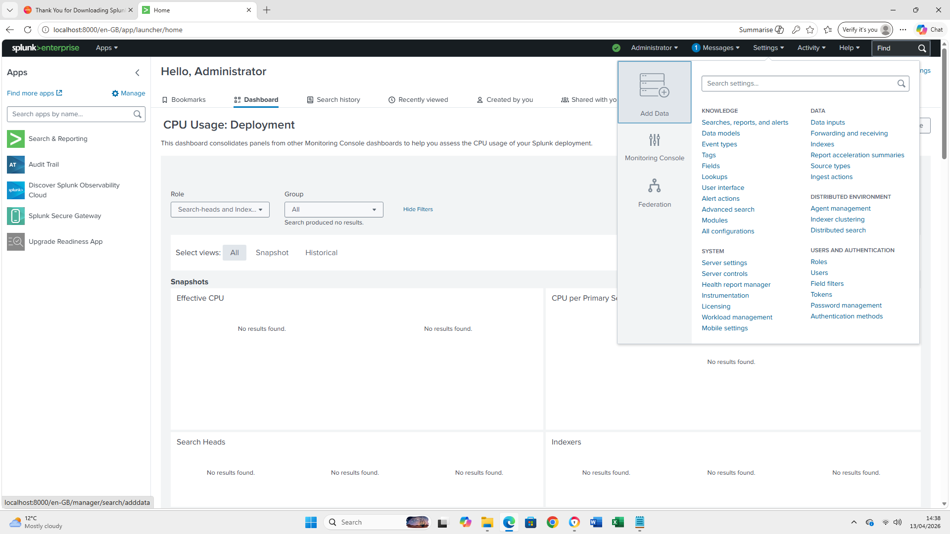

Step 2
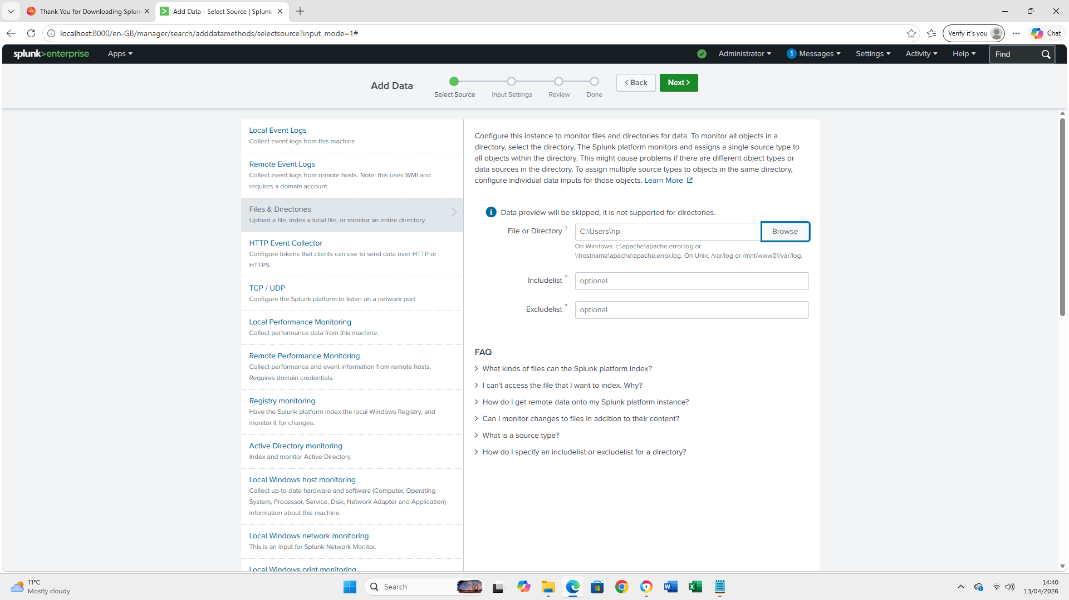
Select a data sorce from the various options ( Local Event Logs, Remote Event Logs, Files and Directories, etc). I've chosen a directory from my local machine.

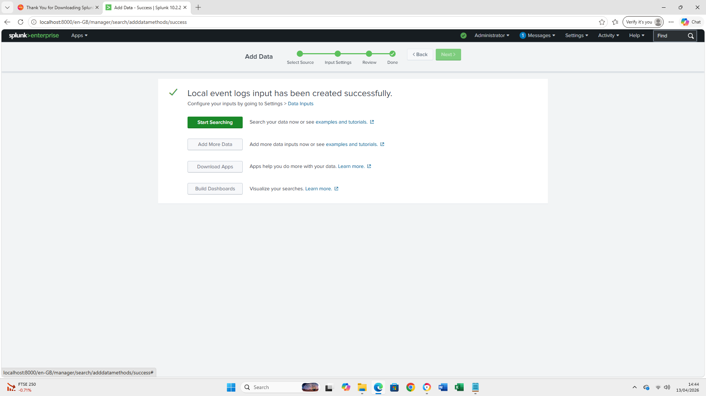
We'll then go through the rest of the steps to finish adding the data source

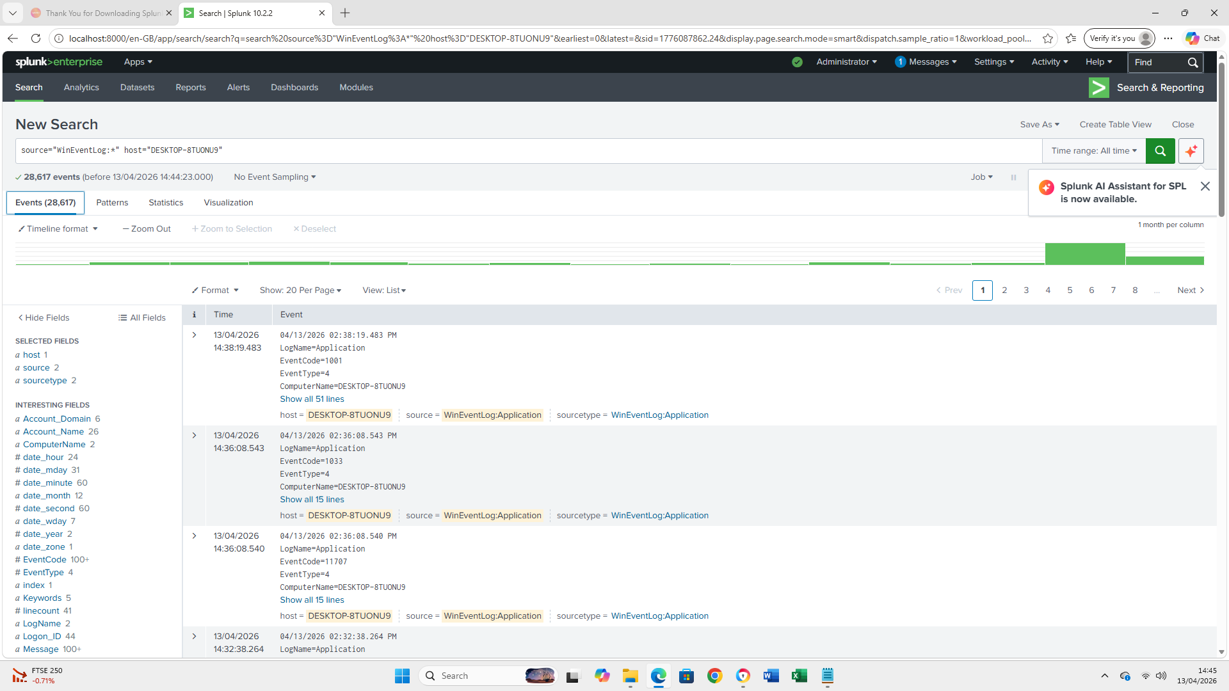
Once the data has been loaded in Splunk you can start searching (analyzing) it. Notice Splunk has found 28617 WinEventLog evenets (top left corner) from the provided source.

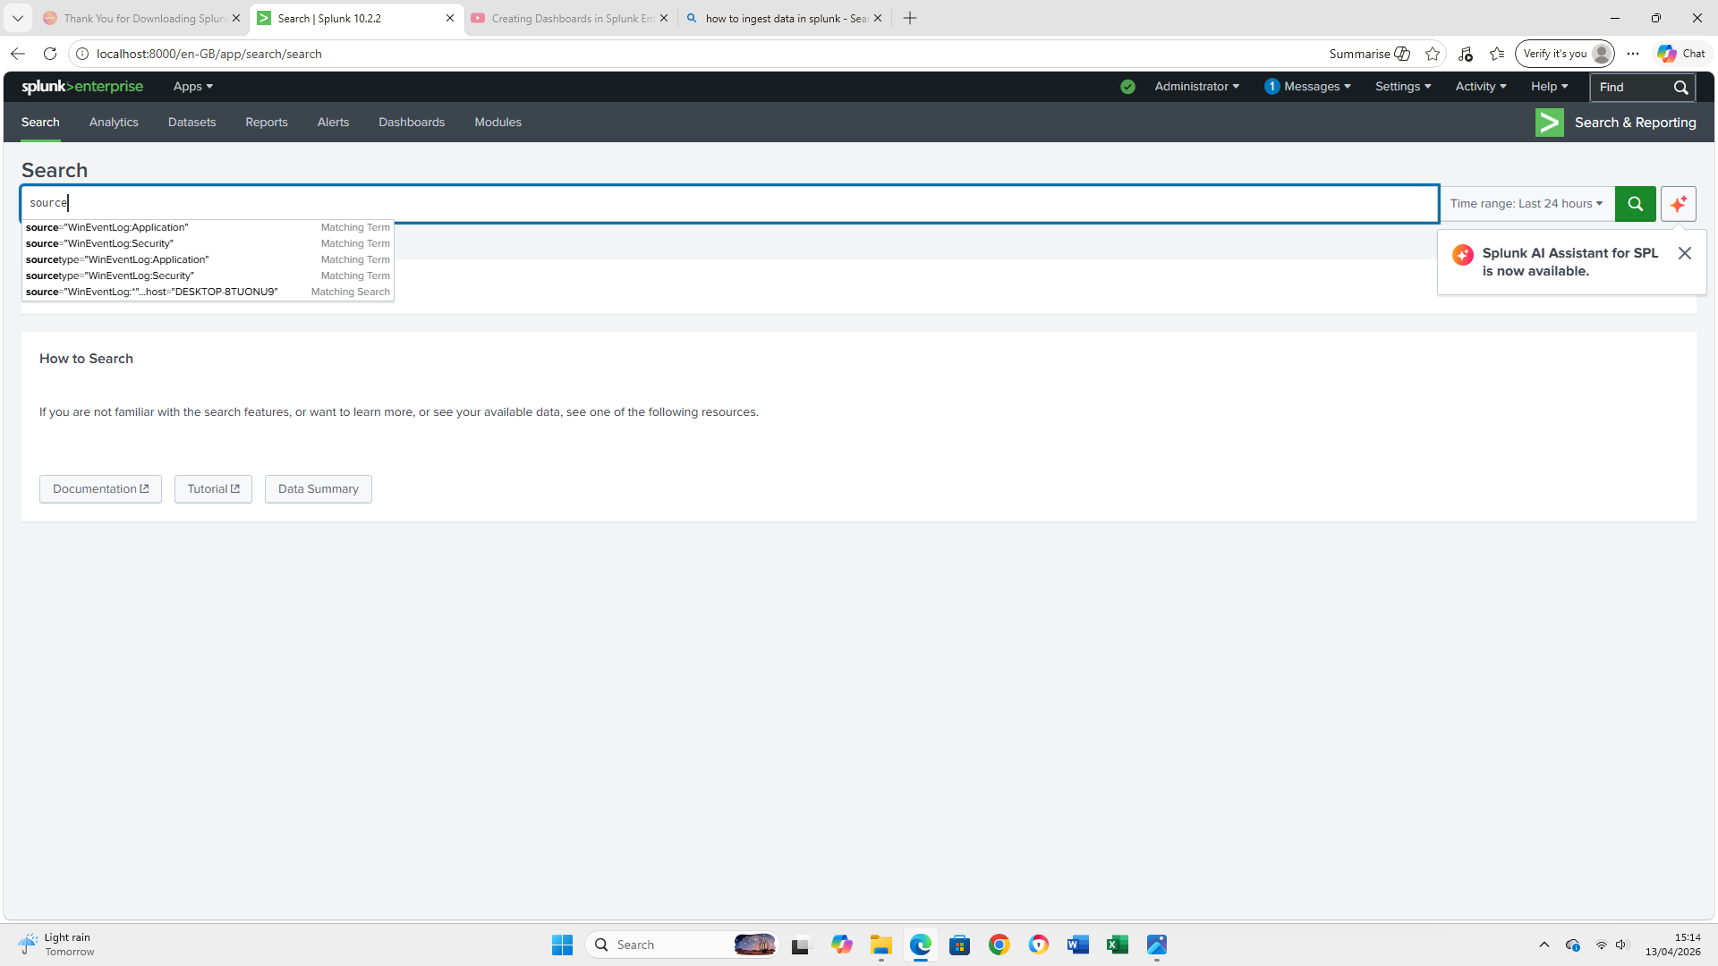
There are many filter options that can be used to display only the data we need to focus on.

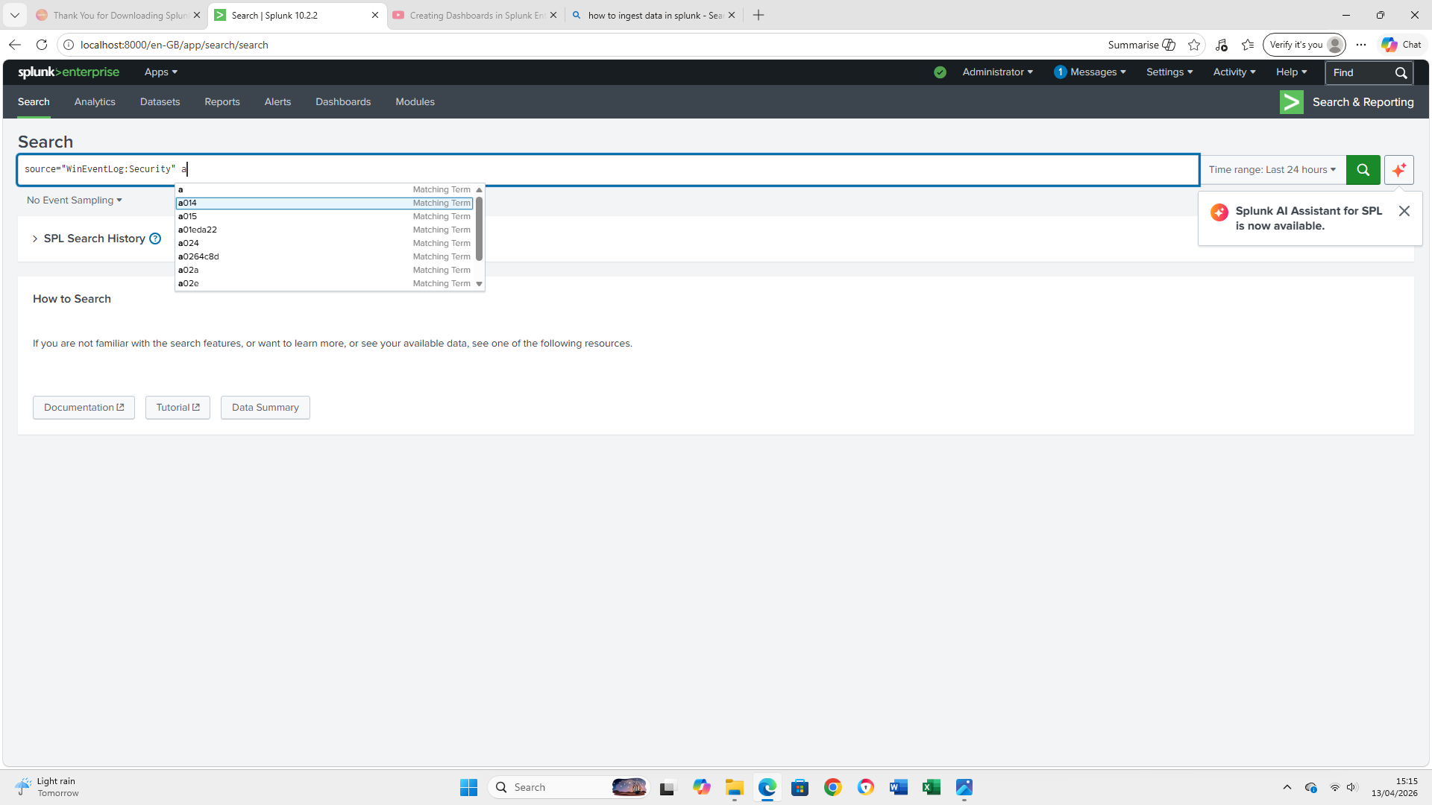

Dashboard setup

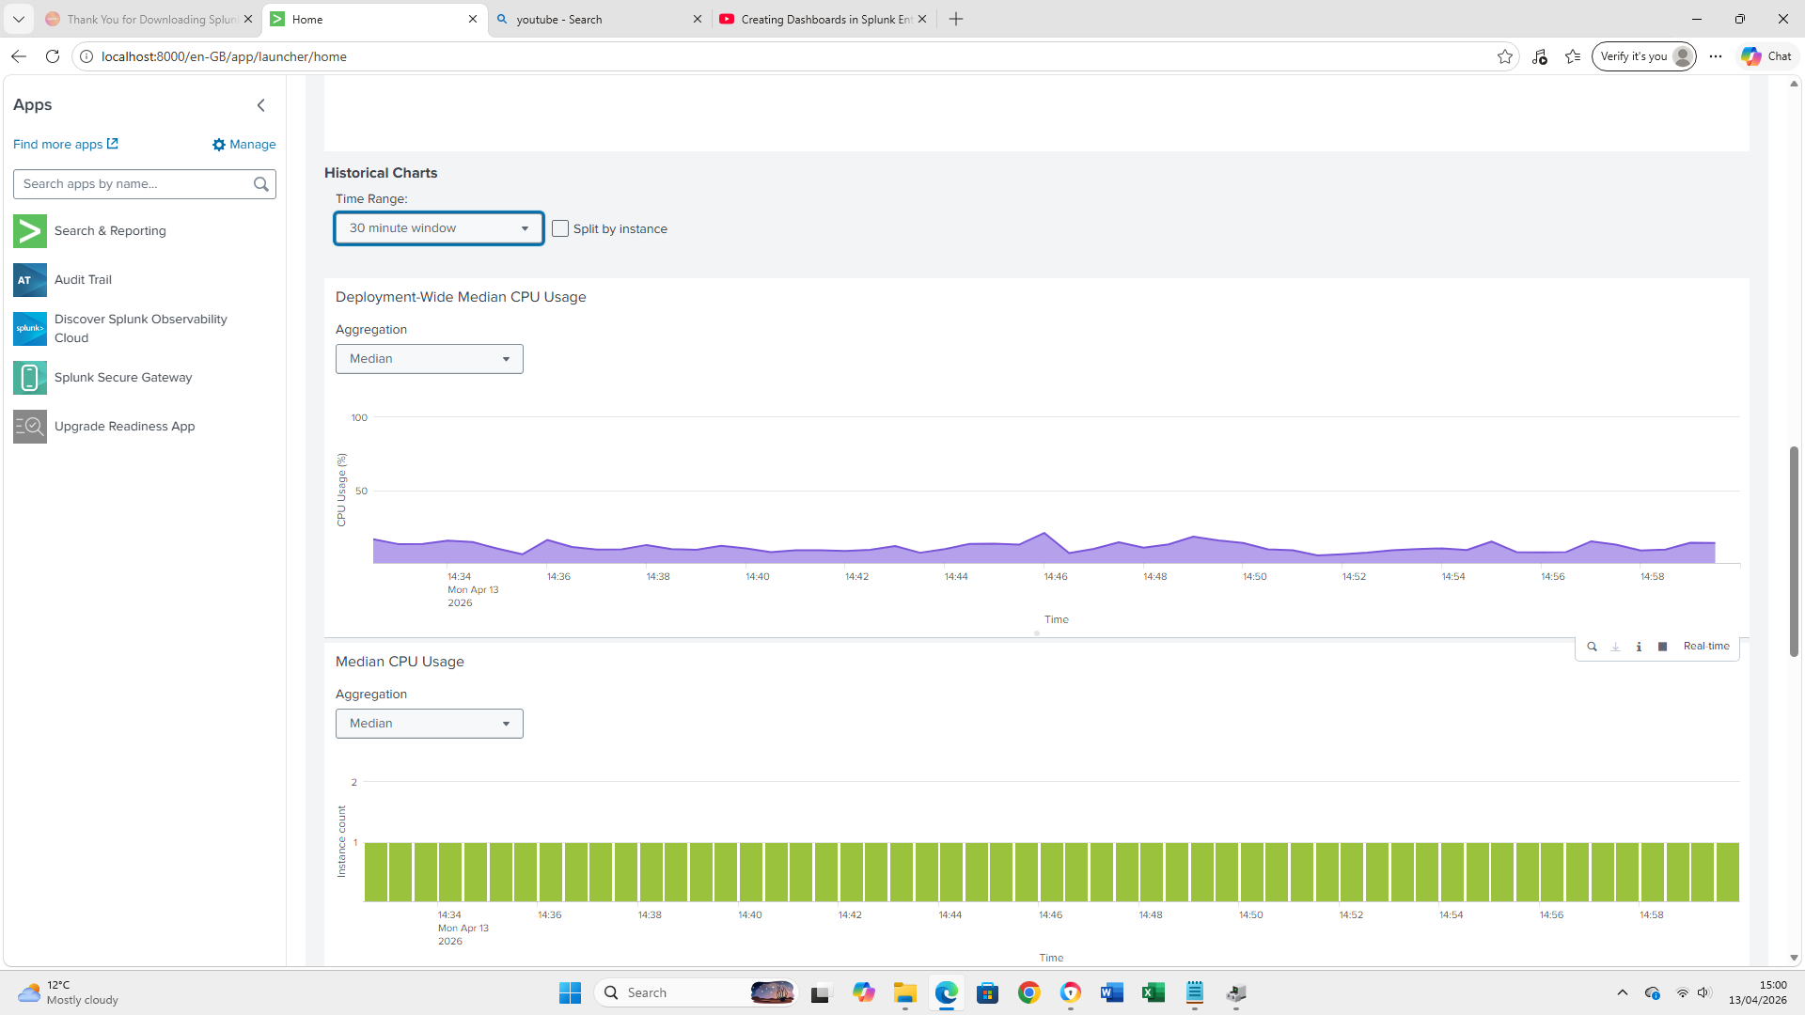
Splunk offers a few dashboards that can be used to visualize data. There are 2 main options: Classic Dashboards (use XML code) and Dashboard studio (modern customizable framework which uses JSON). Can choose to visualize a wide range of metrics categorized into infrastructure, application and network health. For example, I choose to display median CPU usage for the last 30 minutes.

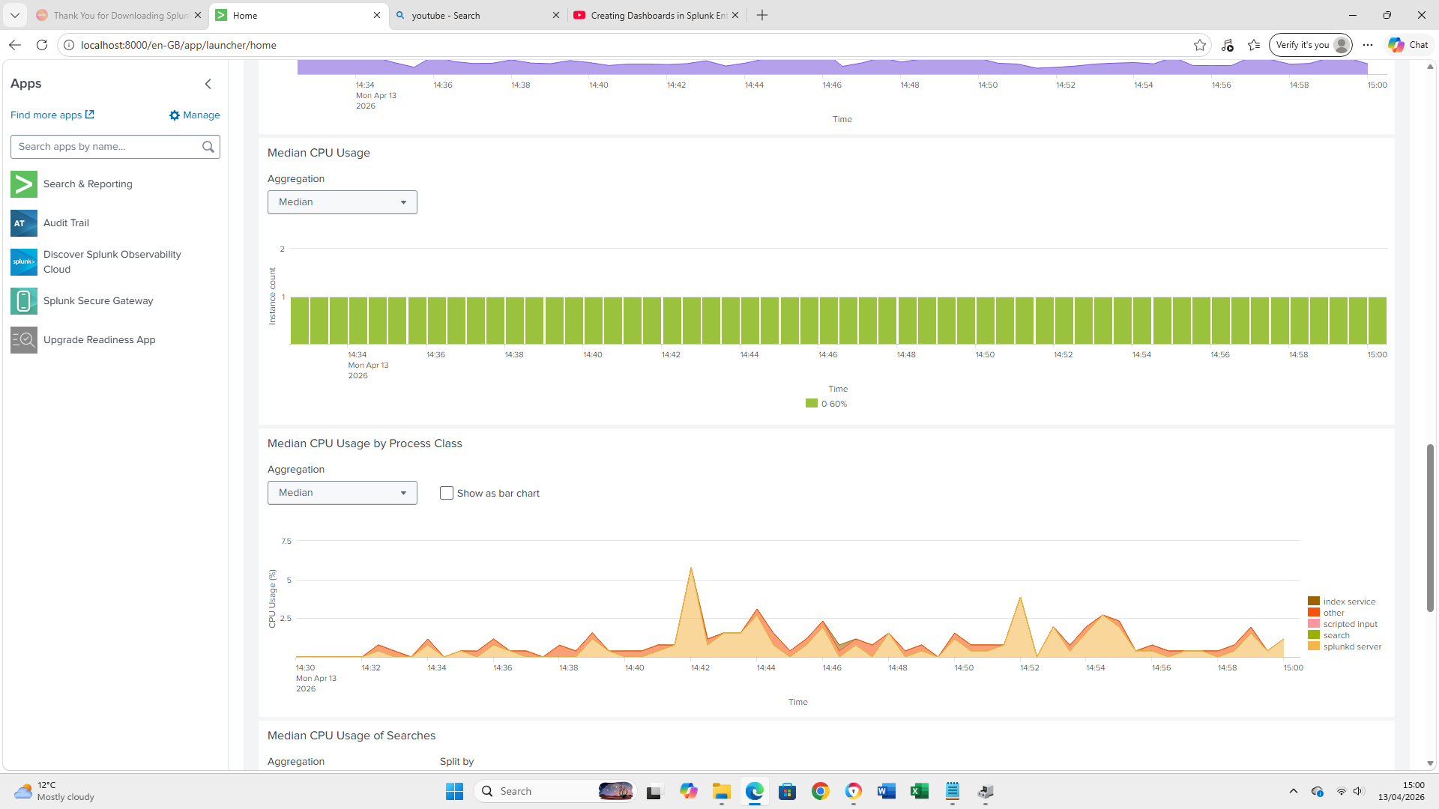


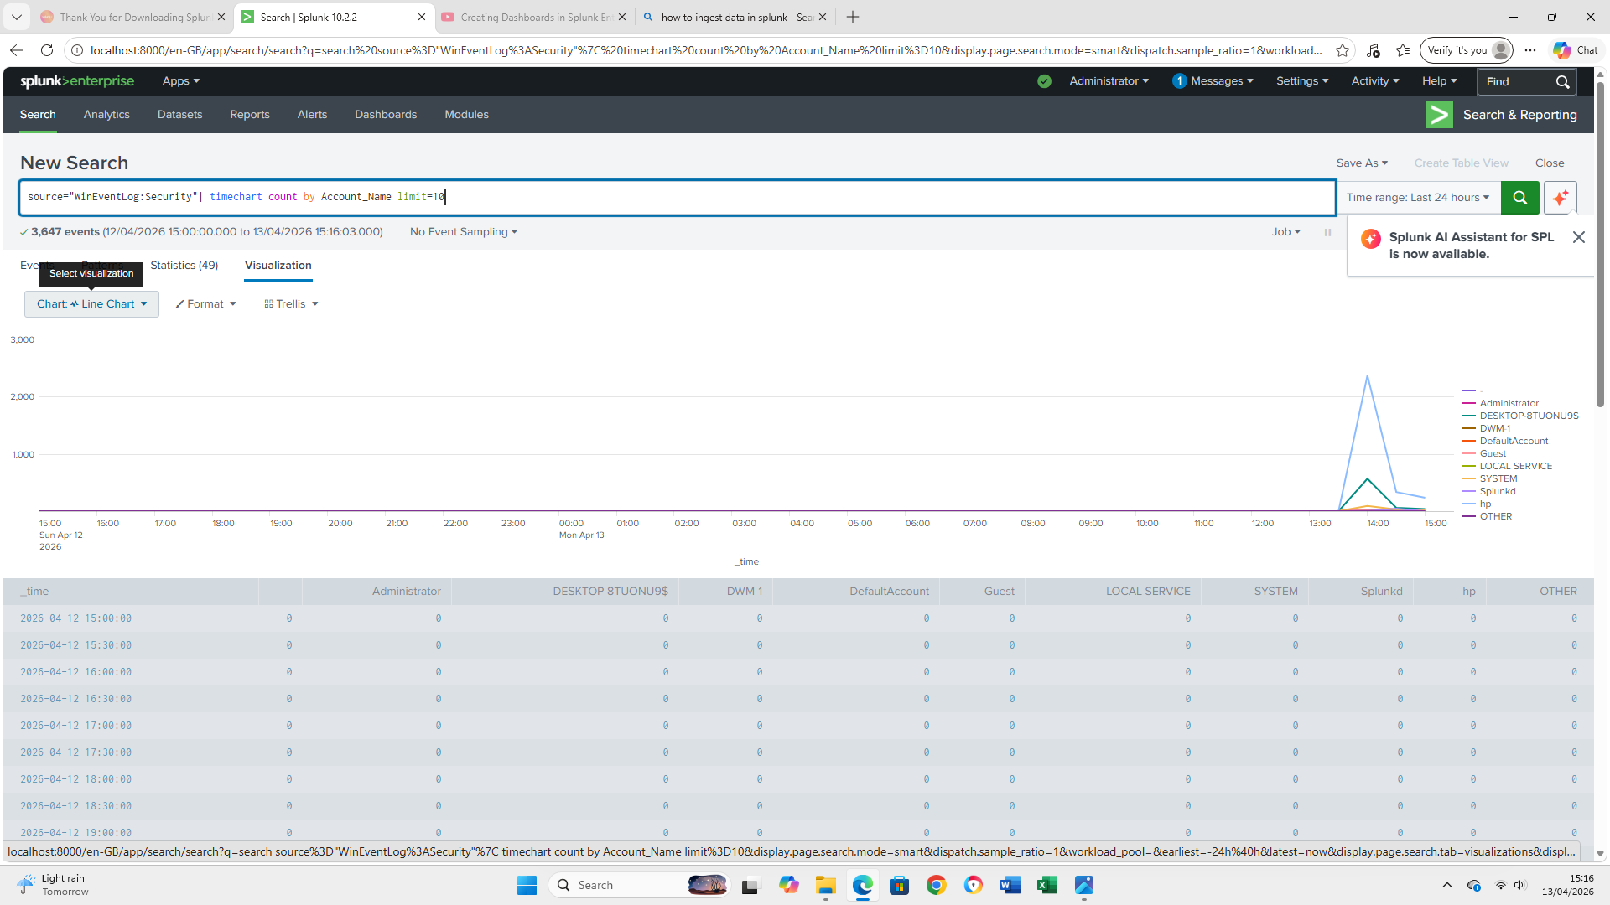
The Splunk Search bar accepts Search Processing Language. SPL is a proprietary query language designed to filter and analyze data. It accepts a few input types such as: search terms & keywords (i.e. error, failed, login, etc), field-value pairs (host=web server, sourcetype=access_combined), boolean operators (e.g. , AND, OR, NOT), wildcards (for example fail* matches failure, failed, etc) and quoted phrases for exact matches (i.e. "database error"). Multiple commands can be chained using the | symbol. This means that the commands that follow the pipe symbol will take the output from the previous command and process it further. This way we can fine tune the results of the search by filtering data that meets certain conditions.
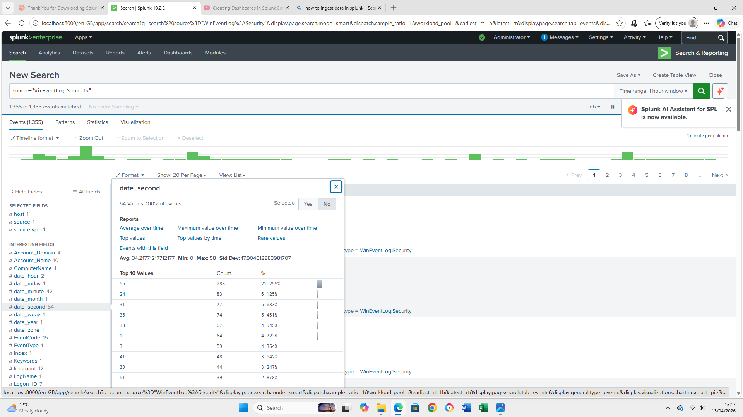
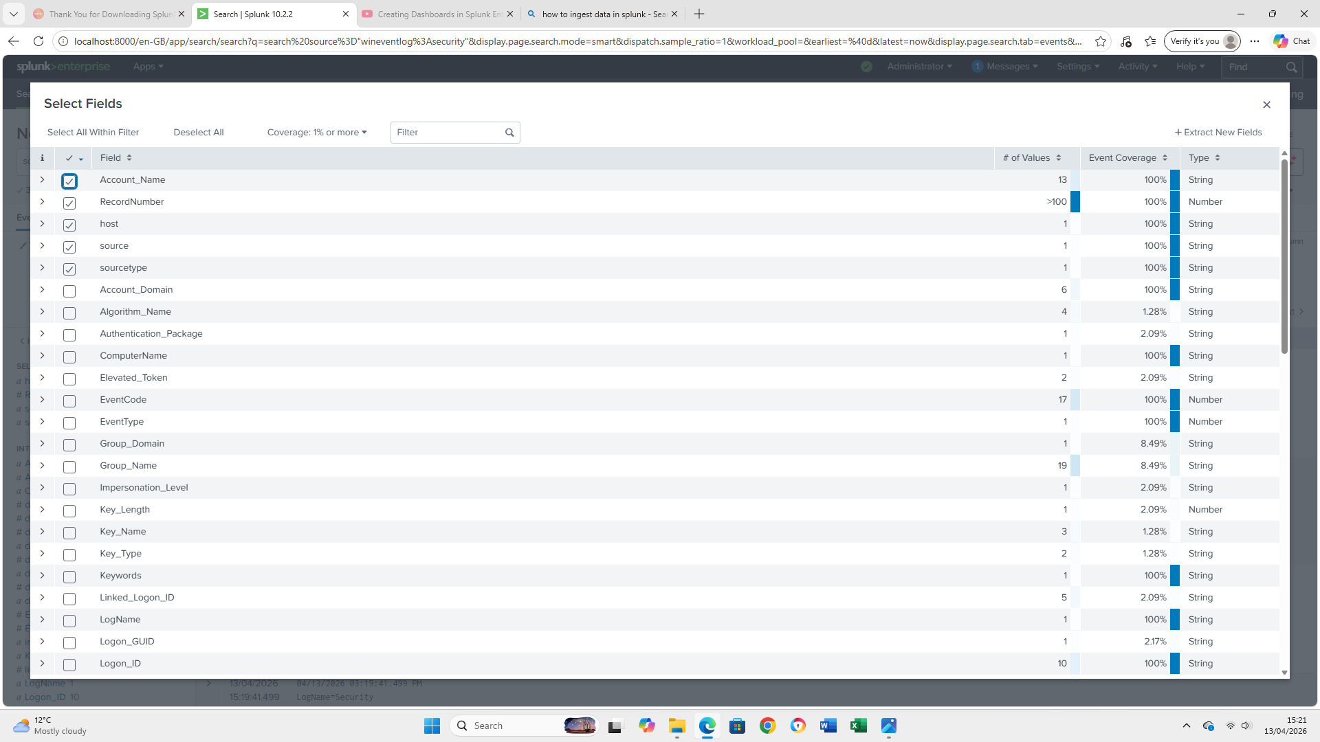
Different fields can be selected from the left pane to tailor the view to our needs.

The dashboards can display different types of charts such as column & bar charts ( to compare values accross categories), line & area charts (showing changes or trends over time), pie & donuts charts (display colored pie slices for different parts that make up the whole pie), etc

